**DIGITAL IMAGE PROCESSING**

Homework 2#

1. Given an original image Figure 1 below

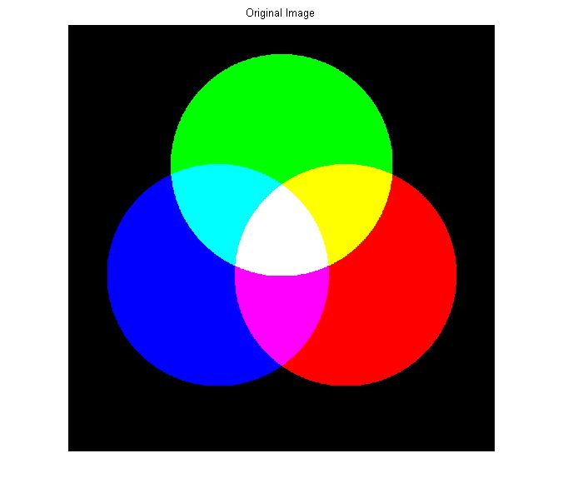

**Fig 1**. Original Image 1

Let’s convert the original image into HSI, then we get Figure 2 below

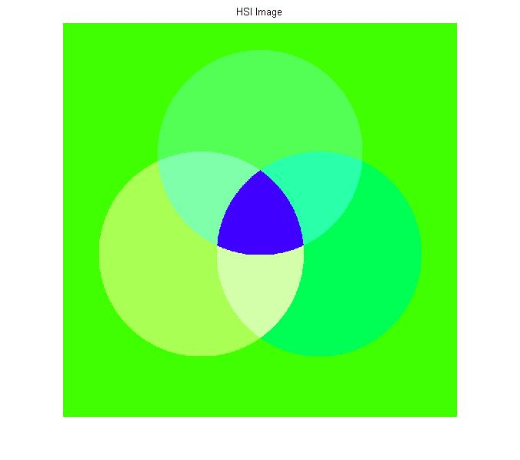

**Fig 2**. HSI Image 1

Then we try to convert back from HIS to RGB image, so that we get Figure 3 below

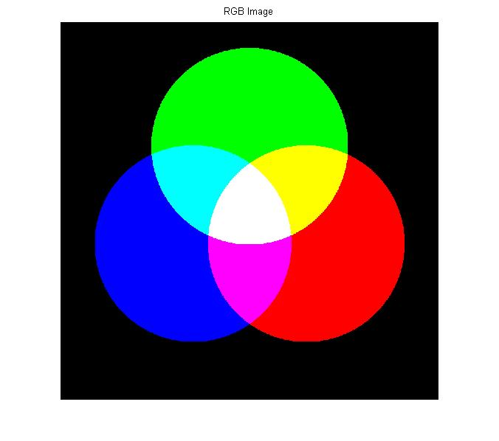

**Fig 3**. RGB Image 1

1. Let’s try using another original image Figure 4 below

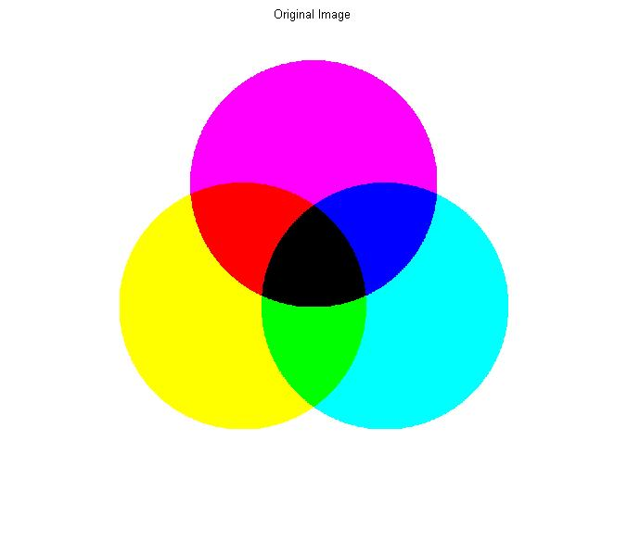

**Fig 4**. Original Image 2

Then we do the same thing as before, converting image form RGB to HSI. Therefore we get figure 5 below

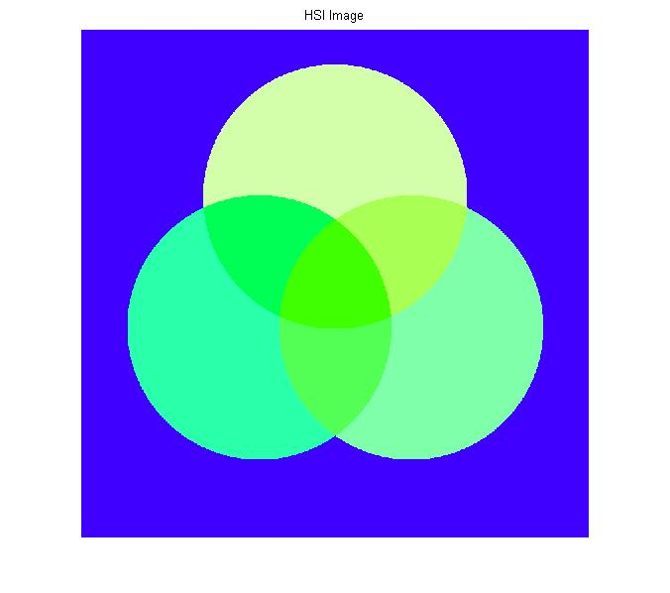

**Fig 5**. HSI Image 2

Let’s convert HIS to RGB, such that figure 6 will be exist

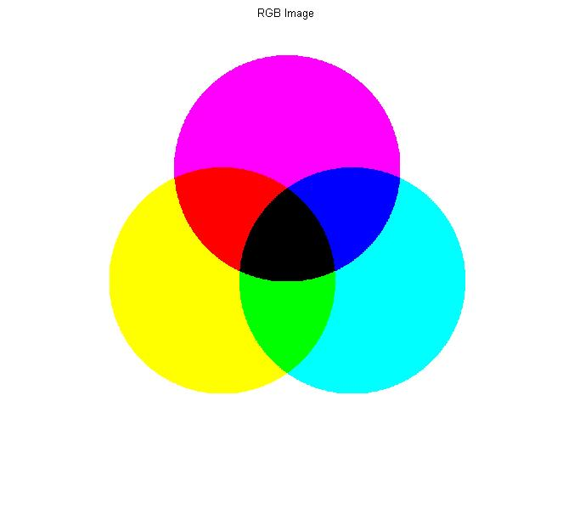

**Fig 6**. RGB Image 2

List Code using Matlab:

* Function to convert RGB to HSI

function img = RGB_HSI(imgSource)

%Convert RGB image in [0 1] range

I=double(imgSource)/255;

R=I(:,:,1);

G=I(:,:,2);

B=I(:,:,3);

num=1/2*((R-G)+(R-B)); %Hue

denum=((R-G).^2+((R-B).*(G-B))).^0.5;

%To avoid divide by zero exception add a small number in the denuminator

H=acosd(num./(denum+0.000001));

H(B>G)=360-H(B>G); %If B>G then H = 360-Theta

H=H/360; %Normalize to the range [0 1]

S=1- (3./(sum(I,3)+0.000001)).*min(I,[],3); %Saturation

I=sum(I,3)./3; %Intensity

%HSI

HSI=zeros(size(imgSource));

HSI(:,:,1)=H;

HSI(:,:,2)=S;

HSI(:,:,3)=I;

img = HSI;

end

* Function to convert HSI to RGB

function img = HSI_RGB(imgSource)

%Get each value (H,S,I) from each channel

H=imgSource(:,:,1);

S=imgSource(:,:,2);

I=imgSource(:,:,3);

%Convert Hue into the range [0 360]

H=H*360;

%Preallocate the R,G and B components

R=zeros(size(H));

G=zeros(size(H));

B=zeros(size(H));

RGB=zeros([size(H),3]);

%RG Sector(0<=H<120)

B(H<120)=I(H<120).*(1-S(H<120));

R(H<120)=I(H<120).*(1+((S(H<120).*cosd(H(H<120)))./cosd(60-H(H<120))));

G(H<120)=3.*I(H<120)-(R(H<120)+B(H<120));

%GB Sector(120<=H<240)

%Subtract 120 from Hue

H1=H-120;

R(H>=120&H<240)=I(H>=120&H<240).*(1-S(H>=120&H<240));

G(H>=120&H<240)=I(H>=120&H<240).*(1+((S(H>=120&H<240).*cosd(H1(H>=120&H<240)))./cosd(60-H1(H>=120&H<240))));

B(H>=120&H<240)=3.*I(H>=120&H<240)-(R(H>=120&H<240)+G(H>=120&H<240));

%BR Sector(240<=H<=360)

%Subtract 240 from Hue

H1=H-240;

G(H>=240&H<=360)=I(H>=240&H<=360).*(1-S(H>=240&H<=360));

B(H>=240&H<=360)=I(H>=240&H<=360).*(1+((S(H>=240&H<=360).*cosd(H1(H>=240&H<=360)))./cosd(60-H1(H>=240&H<=360))));

R(H>=240&H<=360)=3.*I(H>=240&H<=360)-(G(H>=240&H<=360)+B(H>=240&H<=360));

%Set Pixel of each channel

RGB(:,:,1)=R;

RGB(:,:,2)=G;

RGB(:,:,3)=B;

%Convert image into the range [0 255]

RGB=im2uint8(RGB);

img = RGB;

end

* Main Source Code

clc

clear all

close all

imgSource = imread('colorImg1.bmp');

figure,imshow(imgSource); title('Original Image');

imgResult = RGB_HSI(imgSource); % Converting RGB to HSI

imgResult1 =HSI_RGB(imgResult); % Converting HSI to RGB

figure,imshow(imgResult); title('HSI Image');

figure,imshow(imgResult1); title('RGB Image');